

2021-2022 CCS
SCHOOL OPENING & SAFETY PLAN

Crossroads values many things, but when it comes to education at our school, three things have guided our planning for the start of school: Our Learners’ health and well-being, delivering excellent holistic education, and ensuring our school’s long-term stability.

School Year 2021-2022 reopening plan is based on the most current guidance from state agencies and public health officials and will be updated as we receive new guidance.

DATE OF INSTRUCTION FOR 2021-2022 SCHOOL YEAR:
August 18, 2021 –May 26, 2022
  - 1st Semester August 18, 2021, to December 17th, 2021
  - 2nd Semester January 5, 2022, to May 26th, 2022

Section A: Cleaning and Disinfecting
- Cleaning, disinfection, and ventilation of school campuses will follow guidelines developed by the CDPH.
- Campus is cleaned and disinfected daily.
- Restrooms and playgrounds are cleaned and disinfected frequently throughout the day.
- Playground equipment will be regularly inspected and cleaned for student use. Protexus “fogging”
machines will be used to disinfect playground equipment when used.
- Common touch surfaces will be cleaned regularly (e.g., counter tops, door handles, restrooms,
student desks, student chairs, etc.). Anti-microbial film has been installed on every high traffic door handle and countertop.
- Physical barriers have been installed in front office areas where face-to-face interaction with the
public occurs. Physical barriers will be cleaned frequently throughout the day.

We are ensuring that all indoor spaces have sufficient ventilation in all school classrooms and shared workspaces per American Society of Heating, Refrigerating, and Air Conditioning Engineers (ASHRAE) guidance on ventilation. All HVAC systems are operated in occupied mode for a minimum period of 2 hours prior to occupants entering the building. We ensure proper ventilation during cleaning and disinfecting and introduce clean air by opening windows where practicable. We have disabled any demand control ventilation and introduced the maximum possible OA flow 24/7 until further notice.

Section B: Cohort/Stable Groups:
What is a stable group or cohort? A cohort is a stable group with fixed membership that stays together for all courses and activities (e.g., lunch, recess, etc.) and avoids contact with other persons or cohorts.

Reference: https://www.cdph.ca.gov/Programs/CID/DCDC/CDPH%20Document%20Library/COVID-19/ Schools%20Reopening%20Recommendations.pdf

To reduce possibilities for infection, students must remain in the same space and in cohorts as small and consistent as practicable, including for recess and lunch. Keep the same students and teacher or staff with each group, to the greatest extent practicable.

CCS is committed to limit the number of interactions among students and staff together with continued smaller class sizes as well as facilitate an effective and efficient rapid-response contact tracing protocol. Students in preschool through 5th grade will remain in a single cohort during the day, which is easily facilitated by main classroom of instruction and/or grade level. In grades 6th through 12th, cohorts will be preserved by block schedule strategies to limit the number of interactions.
Staff lounge areas and common areas will be arranged to help maintain social distancing. Staff will be encouraged to remain in their grade level pods to limit interactions.

Section C: Entrance, Exits and Movement Within the School
Our goal is to minimize congregate movement through entrances, exits and hallways as much as practicable. Therefore, specific entrances and exits have been designated as well as locations for drop off and pick up in order to ensure limited physical and/or direct contact with others.

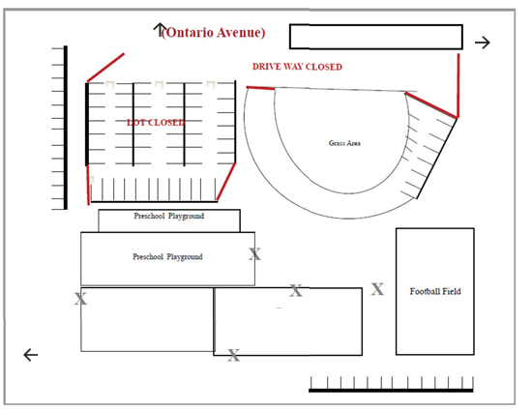

**Parents are encouraged to use the carline for drop oﬀ and pick up.
**Parents & visitors will have limited access to the school campus.

MOVEMENT:
• CCS will limit communal activities where practicable. Alternatively, stagger use, properly space
occupants and disinfect in between uses.
• CCS may consider the use of non-classroom space for instruction, including regular use of outdoor space, weather permitting.
• CCS will limit the number of interactions between cohort groups.
• CCS will operate as a “closed campus” by restricting access of non-essential visitors, volunteers and
group activities during regular hours of operation.
• CCS will limit the number of individuals in the front office, ensuring proper physical distancing is maintained.
• To further minimize hallway movement, CCS does not have student lockers.

STAGGERED START TIME AND OTHER SCHEDULES:
Staggered start times and break schedules have been established for different grade levels to aid in limiting physical and/or direct contact with others. Snack and lunch times will be limited to grade level cohorts.
Kindergarten start time is 8:00am-2:30pm
1st-5th Grade start time is 8:00am-2:45pm
7-8th Grade start time is 8:00am-3:00pm
9-12th Grade start time is 8:00am-3:00pm

Parents & visitors will have limited access to the school campus. Upon entering everyone will have their temperature checked using a no-contact thermometer.

PHYSICAL BARRIERS:
Physical barriers have been installed in front office areas where face-to-face interaction with the public occurs

Section D: Face Coverings and Other Essential Protective Gear

FACE COVERING:
In accordance with the California Department of Public Health’s (CDPH) Guidance for Face Coverings:

- All Staff, learners, and other adults (volunteers, visitors, etc.) arriving on campus must wear a face covering or in limited instances, a face shield with drapes unless they meet face covering exemptions. Students and staff should be frequently reminded not to touch the face covering and to wash their hands frequently.
Reference: https://www.cdc.gov/coronavirus/2019-ncov/community/schools-childcare/k-12-guidance.html

Parents should be familiar with the face covering exemptions as they will be responsible for determining the exempt status of their child. Learners with no face covering exemption must bring a face covering with them to be used if physical distancing is not feasible.

STAFF/LEARNERS

AGE | FACE COVERING REQUIRED
Under 2 years old | No
Preschool | No
Kindergarten - High School | Yes, unless exempt
Learners exempt from wearing a face covering will not be required to use a face covering, but must wear a non-restrictive alternative, such as a face shield with a drape on the bottom edge if their condition permits it.
Reference:
- Guidance for the Use of Face Coverings
- Your Guide to Masks

Information regarding face coverings and exemptions:
Visit the California Department of Public Health’s website at:
- Guidance for the Use of Face Coverings
- Guidance for COVID-19 Prevention in K-12 Schools

Learners must use face coverings:
- While in the classroom or indoors
- Personal face covering will be allowed in compliance with the dress code policy

Masks are optional outdoors.

Staff members must use face coverings when:
- Must use face covering at all times while indoors.
- Interacting in-person with any member of the public.
- Working in any space visited by members of the public, regardless of whether anyone from the
- public is present at the time.
- Working in any space where food is prepared or packaged for sale or distribution to others.
- Working in or walking through common areas, such as hallways, stairways, elevators, in a vehicle
- traveling with others, and parking facilities.
- In any room or enclosed area where other people are present when unable to physically distance.
- Face coverings and gloves must be used by staff who work with students who require more hands-
- on services.
- Facilitators/Staff can use face shields when modeling of oral tasks is required to complete to allow learners to view their Facilitators/Staff.
- Staff will be provided reusable cloth face masks and face coverings, and are expected to wear them
daily.
- Personal face coverings will be allowed in compliance with CCS dress code policy

Personal Protective Equipment (PPE)
PPE will be available to staff and learners.
- CCS has different types of face covering and staff will be given a choice as to type of face covering
they would like to use and/or most conducive to their student’s needs.
- Face coverings and gloves must be used by staff who work with students who require more hands- on services.
**Gloves are not recommended for use by learners or staff, with the exception of those conducting cleaning, first aid, or food service

The following individuals are exempt from wearing a face covering:
- Persons age two years or under. These very young children must not wear a face covering because
of the risk of suffocation.
- Persons with a verified medical condition, mental health condition, or disability that prevents wearing a face covering. This includes persons with a medical condition for whom wearing a face
covering could obstruct breathing or who are unconscious, incapacitated, or otherwise unable to remove a face covering without assistance.
- Persons who are hearing impaired or communicating with a person who is hearing impaired, where
the ability to see the mouth is essential for communication.
- Persons for whom wearing a face covering would create a risk to the person related to their work, as determined by local, state, or federal regulators or workplace safety guidelines.

For more information regarding face coverings and exemptions, please visit the California Department of Public Health’s website at:

- Guidance for the Use of Face Coverings
- Your Guide to Masks

Section E: Health Screening for Students and Staff

SYMPTOMS OF COVID-19:
We are required to share information regarding Covid-19 symptoms.
Remember, anyone can have mild to severe symptoms. Older adults and people who have severe underlying medical conditions like heart or lung disease or diabetes seem to be at higher risk for developing more serious complications from COVID-19 illness.

People with COVID-19 have had a wide range of symptoms reported – ranging from mild symptoms to severe illness.

Symptoms may appear 2-10 days after exposure to the virus. People with these symptoms may have COVID-19:
- Fever or chills
- Cough
- Shortness of breath or difficulty breathing
- Fatigue
- Muscle or body aches
- Headache
- New loss of taste or smell
- Sore throat
- Congestion or runny nose
- Nausea or vomiting
- Diarrhea
- Fever (100.4 degrees or higher)
This list does not include all possible symptoms. CDC will continue to update this list as we learn more about COVID-19.

SELF-CHECK AT HOME:
All CCS Staff, learners, and other adults (families, guests, and volunteers, etc.) must conduct symptoms self-check and temperature check prior to arriving on our campus.
- If you are experiencing any symptoms and/or have a fever of 100 degrees or higher you need to
stay home until you are no longer experiencing any symptoms to ensure your safety as well as the safety of those around you. If you need information on what symptoms to look for, please go to the CDC link: https://www.cdc.gov/coronavirus/2019-ncov/symptoms-testing/symptoms.html

**Quarantine, personal illness and Covid-19 illness or symptoms related absence will be excused.

SCREENING ON CAMPUS PRIOR TO ENTRY:
1. All Staff, learners and visitors must complete a self-check prior to arriving on campus.
2. A health screening including a no-contact temperature check will be done before entering the main campus.
3. All Staff, learners and visitors must be symptom free prior to starting school, work, or entry to the campus.
a. Staff who are symptomatic for COVID-19 must stay at home and contact Human Resources.
b. Learners who are symptomatic for Covid-19 must stay home and notify the school of the absence.
c. Visitors who are symptomatic will not be allowed on campus
** Parents & visitors will have limited access to the school campus. Upon entering everyone will have their temperature checked using a no-contact thermometer.

Any staff or learner exhibiting symptoms will immediately be required to wear a face covering and wait in an isolation area until they can be transported home or to a healthcare facility, as soon as practicable.
- Staff that present symptoms while at school/work must immediately contact their supervisor and campus safety office. They will immediately isolate themselves from others and go home.
- Learners that present symptoms while at school will immediately go to a designated isolation area until they can be picked up by a parent or guardian.

**Note: Parents must be prepared to pick up their learner(s) immediately in the instance they develop COVID-19 symptoms while at school. Please be sure to have updated emergency contacts in Facts.

Section F: Healthy Hygiene Practices

HAND WASHING AND HAND SANITIZERS:
- Staff and learners are expected to wash/sanitize their hands regularly.
- Staff and learners are required to wash/sanitize their hands upon entering the classroom throughout
the day.
- Hand sanitizers will be available in every classroom and workstation.
- There are hand sanitizer stations in all front offices, in classrooms and high traffic areas.
- Most Elementary and Middle School classrooms have in-classroom sinks.
- There is a sink available in the High School Lab and convenient bathroom access is available.

SHARING OF SUPPLIES AND TRASH CANS
- Sharing of supplies will be limited and avoided between learners and staff to the extent possible.
- Learners must take home personal items for cleaning daily.

WATER BOTTLE AND DRINKING FOUNTAIN
- Students must bring a refillable water bottle or have an option to use a disposable cup.

Section G: Identification, Tracing and Communication

COVID-19 PROTOCOL & NOTIFICATION
Should a positive COVID-19 case occur at school, the following protocols will be followed:
- In accordance with state and local laws and regulations, school administrators will notify local health officials, staff, and families immediately of any case of COVID-19 while maintaining confidentiality in accordance with the Americans with Disabilities Act (ADA).
- Privacy of Employee Medical Information
- CCS is entitled under California’s Confidentiality of Medical Information Act to establish appropriate
procedures in regard to received medical information of employees to ensure the confidentiality and protection of unauthorized uses of that information.
- CCS will not disclose the name(s) of infected employees unless such disclosure is to public health
authorities or required by law. Crossroads Christian Church will keep information regarding employee illness as confidential medical information, in compliance with ADA requirements.
- Students' information and records will follow FERPA and HIPAA guidelines
- Determine and inform those who have had close contact with a person diagnosed with COVID-19
to self- monitor for symptoms and follow state and local guidance if symptoms develop.
**CCS will be using an electronic visitor management system (Raptor Technologies) to monitor visitors on campus. Student Attendance will be tracked by Canvas. Staff attendance is tracked by Paylocity and Secure Access Entry Fobs.
- Learner, Staff, and families who are been identified as close contact exposure to a positive COVID- 19 case will be notified.
- Notification for Learners: These notifications will be completed by Campus Safety Office or CCS Leader or designee by phone with follow-up written correspondence.
- Notification of Staff: These notifications will be completed by Campus Safety Office or CCS Leader or designee by phone with follow-up written correspondence. Human Resources will also be notified.
- Staff are required to comply with CDPH and Cal/OSHA requirements on vaccine verification, testing, and quarantine protocols
  - Vaccine Verification for Workers in Schools
SCHOOL CLOSURE: (+) COVID-19 cases may lead to the closure of a classroom, multiple classrooms, or even a school. This will be determined by CCS with direction from Riverside County Public Health.

RECORDKEEPING
CCS will keep logs of:
- Classes (Using Canvas & Facts Management)
- Seating charts (Using Canvas)
- Playground usage & snack/lunch times (Using Canvas)
- Daily visitors who are approved to enter the school (using Raptor Technologies)
- Staff on campus (using Key fobs & Paylocity)
- Parents on campus (using Raptor Technologies)
- CCS will maintain these records and the records will be readily available for public health for contact
tracing purposes.

STAFF AND LEARNERS THAT PRESENT ANY SYMPTOMS:

COVID SYMPTOMS LIST
- Fever or chills
- Cough (New, uncontrolled)
- Shortness of breath or difficulty breathing (not due to asthma)
- Fatigue/Muscle or body aches
- Headache
- New loss of taste or smell
- Sore throat
- Congestion or runny nose
- Nausea or vomiting, Diarrhea
- Fever (100 degrees or higher)

Staff and Learners who present symptoms will be sent home.

Staff must report immediately to their supervisor and Campus Safety Officer

Learner must report immediately to their facilitator
  - Learners will go to a designated isolation area until they can be picked up by a parent or guardian
  - Staff will go to a designated isolation area and make arrangements to go home immediately

Staff and Learners may return to school the next day if they are not experiencing any symptoms and have not taken a fever reducing medicine in the last 24 hours (i.e., Ibuprofen, Acetaminophen)

If tested for Covid-19 and received a negative test result (PCR Test only) learner may return to school 24 hours after symptoms are fully resolved (without fever medication use). However, if staff/learner continues to have symptoms, they must continue to stay home and consider conducting another test

If tested for Covid-19 and received a positive test result, staff/learner must remain home until all the following have been met:

10 days have passed from last positive test

24 hours have passed since last fever without the use of fever-reducing medication

Symptoms have fully resolved

If staff/learner was not evaluated by health care provide and did not get a test, staff/learner must remain home until all the following have been met:

10 days have passed from initial onset of symptoms

24 hours have passed since last fever without the use of fever-reducing medication

Symptoms have fully resolved
- CCS will make arrangements with the student and families to be able to continue with school while at home to ensure that the student’s learning is not impacted.

LEARNER WITH CONFIRMED COVID-19 POSITIVE TEST:

Must remain home until all the following have been met:

10 days have passed from last positive test

24 hours have passed since last fever without the use of fever-reducing medication

Symptoms have fully resolved

Learners are encouraged not to retest for at least 90 days (unless known exposure and symptomatic)
  - CCS will make arrangements with the student and families to be able to continue with school while at home to ensure that the student’s learning is not impacted.

LEARNER EXPOSED TO A CONFIRMED COVID-19 CASE (CLOSE CONTACT):

Stay home for at least 10 days from the onset of symptoms.
  - May return to school after 10 days from the onset of symptoms if they are not experiencing any symptoms and has not taken a fever reducing medicine in the last 24 hours (i.e., Ibuprofen, Acetaminophen)
  - May test starting on 6th day of staying home and if test (PCR Test only) is negative and not experiencing and exhibiting any symptoms may request CCS to allow learner to return to school. Request must be sent to the Campus Safety Officer to get clearance to return on day 8. (At-home tests will not be accepted)
  - CCS will make arrangements with the student and families to be able to continue with school while at home to ensure that the student’s learning is not impacted.
  - Stable groups (cohort) exposed to confirmed Covid-19 case will be excluded from school for 10 days from last date of exposure to a confirmed (+) Covid-19 Case that occurs within the same stable group.

**Note: Parents must be prepared to pick up their learner(s) immediately in the instance they develop COVID-19 symptoms while at school. Please be sure to have updated emergency contacts in Facts.

STAFF WITH CONFIRMED COVID-19 POSITIVE TEST OR CONFIRMED COVID-19 CASE:
Follow CDPH Protocol: CDPH PROTOCOL FOR SCHOOL STAFF

EXEMPTION FROM QUARANTINE:

Staff and learners who have tested positive for COVID-19 do not need to quarantine or get tested again within 3 months if they do not develop symptoms again.

Staff who are fully vaccinated with an exposure to a COVID-19 case are not required to quarantine if they meet the following:

Fully vaccinated (> 2wks following last dose)

Asymptomatic since the most current COVID-19 exposure

STAFF AND LEARNERS RETURNING TO SCHOOL AFTER A DIAGNOSIS OF COVID-19
Staff and learners must be cleared by Human Resources and/or Campus Safety Officer before returning to work/school.
Parents must notify CCS prior to learner returning to school.
- After a positive diagnosis is made, students should expect to be in quarantine for at least 10 days after the test, and potentially longer if they continue to remain symptomatic.

COMMUNICATION PLAN:
CCS is committed to ensuring open and timely communication with families. Should there be a confirmed case or a known exposure to COVID-19 on campus a notification will be sent out to impacted staff and learners. Furthermore, CCS will maintain contact with the Riverside County Health Office and CPDH. CCS has procedures in place for investigating communicable disease cases & Covid 19.
- Staff or Learner with Covid-19 Symptoms:
  - Communication: No action needed
- Staff of Learner with confirmed exposure with a Covid-19 positive case:
  - Communication: Notification of a known exposure to impacted individuals and families. No communication needed if exposure did not occur in CCS
  - School remains open
  - Stable groups (cohort) exposed to confirmed Covid-19 case will be excluded from school for 10 days from last date of exposure to a confirmed (+) Covid-19 Case that occurs within the same stable group.
- Staff or Learner with confirmed COVID-19 infection
  - Communication: Notification of a known case exposure. No action needed if exposure did not occur in CCS
  - School remains open

Section H: Physical Distancing
Physical distancing helps limit the spread of the virus.

PHYSICAL DISTANCING STRATEGIES INCLUDE:
- CCS will operate as a “closed campus” by restricting access of non-essential visitors, volunteers, and group activities during regular hours of operation.
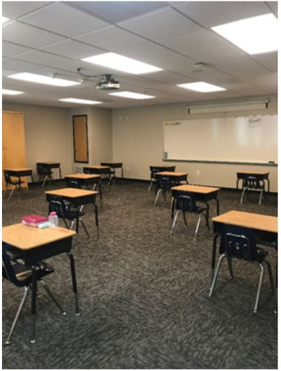
- Classroom and other learner spaces will be arranged to allow maximum space for learners and staff to maintain physical distancing.
- Classroom set up includes learners’ desks to face the same direction (not facing each other), spaced with appropriate physical distance (3-4ft) between desks as well as spaced 3-4 feet from facilitators.
- Student chairs will be set up at least 3-4 feet away from one another, except where 4 feet of distance is not possible after a good-faith effort has been made.
- Short term exposures of less than 3-4 feet between students and staff are permitted (e.g., a teacher assisting a student one-on-one), but the duration should be minimized and masks must be worn.

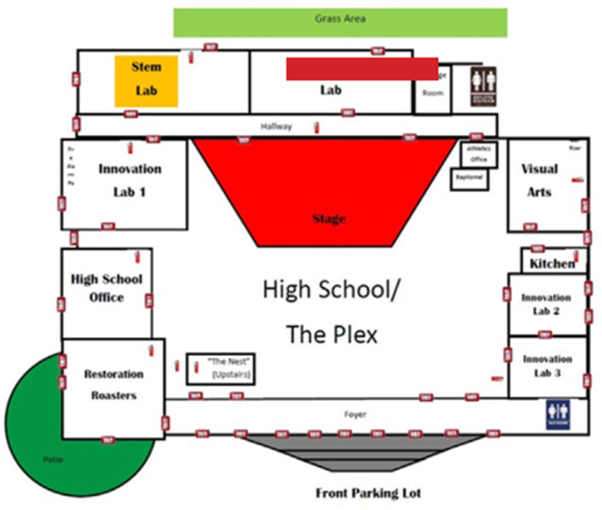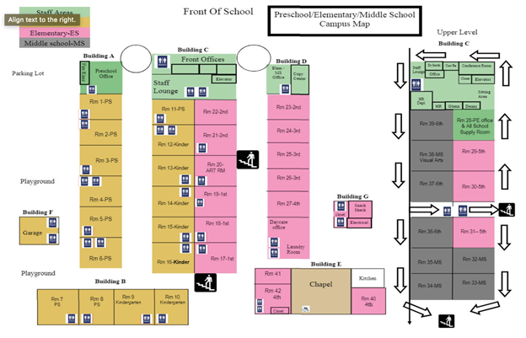

- Entrance, exit and traffic flow paths have been planned for breaks, lunch, recess, and other transition times.
- Staff will practice physical distancing, including but not limited to, the following:
  - Working indoors or in outdoor areas
  - Before and after the work shift
  - Coming and going from vehicles
  - Entering, working, and exiting physical buildings or other structures during breaks and lunch periods

PLAYGROUND USE AND SPORTS
Playground:
Learners will have access to playground equipment but will be encouraged to maintain physical distancing where possible. Playground equipment will be regularly inspected and cleaned for student use.

Sports:
The purpose of reopening guidelines for our athletic departments in the CCS is to ensure the safest environment and best possible care is being provided for our students who choose to return and participate in these activities.
The California Interscholastic Federation (CIF) Sports Medicine Advisory Committee has developed a comprehensive document to help school districts prepare for their student-athletes to return to athletic activities. Reference: https://cifstate.org/covid-19/index

Food Services
When available, Food Services will provide boxed or individually plated meals and will eat lunch in designated lunch areas in or outside of the classroom.

Section I: Staff Training and Family Education

TRAIN ALL STAFF AND EDUCATE LEARNERS AND FAMILIES

Train all staff and provide information to families in the following safety actions:

Proper use, removal, and washing of face coverings.

Physical distancing guidelines and their importance.

Symptom's screening practices.

COVID-19 specific symptom identification

How COVID-19 is spread.

Enhanced sanitation practices.

The importance of staff and students not coming to work they have symptoms, or if they or someone they live with or they have had close contact with has been diagnosed with COVID-19.

For staff, COVID-19 specific symptom identification and when to seek medical attention.

The employer’s plan and procedures to follow when staff or students become sick at school.

The employer’s plan and procedures to protect staff from COVID-19 illness.

STAFF TRAINING
Staff members will complete mandated COVID-19 training which includes information on Hand Washing, Coronavirus Awareness, Center for Disease Control (CDC), Guidelines for Using Face Coverings, and Coping with Covid-19 and managing Covid-19 anxiety.

FAMILY EDUCATION
CCS has compiled resources and websites for parents and learners, including our opening plan details, to help with the impact of the novel coronavirus (COVID-19). These resources will be available and distributed from our school website or classroom connection.

Learners will be trained in hand washing, covid19 symptoms, and social distancing.

Parents are encouraged to recognize the symptoms of Covid 19 and learn how to help their learner manage and cope with the new procedures.

CAMPUS SIGNAGE AND FLOOR DECALS
We have taken reasonable measures, including posting signage and floor decals in strategic and highly visible locations, to remind staff/learners/visitors of the use of face coverings, practice of physical distancing, hand washing and cleaning and sanitation.

CCS has posted various signage around campus to help educate our school community about Covid 19.

Section J: Protocols for Staff: Testing and Vaccine Verification
CCS follows California State and Riverside County Public Health Guidance and Cal/OSHA Requirements.
Protocols for School Staff
Vaccine Verification for Workers in Schools

HIGH RISK EMPLOYEES
Staff who are in the high-risk group and are concerned about coming to work should contact Human Resources.

Based on what we know now, those at high-risk for severe illness from COVID-19 are:
- People 65 years and older
- People who live in a nursing home or long-term care facility
- People of all ages with underlying medical conditions, particularly if not well controlled, including:
- People with chronic lung disease or moderate to severe asthma People who have serious heart
- conditions
- People who are immunocompromised
- Many conditions can cause a person to be immunocompromised, including cancer treatment,
- smoking, bone marrow or organ transplantation, immune deficiencies, poorly controlled HIV or AIDS, and prolonged use of corticosteroids and other immune weakening medications
- People with severe obesity (body mass index [BMI] of 40 or higher) People with diabetes
- People with chronic kidney disease undergoing dialysis People with liver disease
- Pregnant people might be at an increased risk for severe illness from COVID-19 compared to non-
- pregnant people

The best ways to protect yourself and to help reduce the spread of COVID-19 are to:
- Limit your interactions with other people as much as possible
- Take precautions to prevent getting COVID-19 when you do interact with others
- If you start feeling sick and think you may have COVID-19, call your healthcare provider within 24
Hours

Section K: Triggers for switching to distance learning:

CCS follows California State and Riverside County Public Health and CDC Guidance

The school closure, in which all learners and staff are not on campus, is recommended based on the number of cases and stable groups impacted which suggest that active in-school transmission is occurring. Closure should be done in consultation with the Riverside County Health Department. Situations that may indicate the need for school closure:

Within a 2-week period, an outbreak has occurred in 25% or more stable groups in the school.

Within a 2-week period, at least three outbreaks have occurred in the school AND more than 5% of the school population is infected.

The RCHD may also determine school closure is warranted for other reasons, including results from public health investigation or other local epidemiological date.

Length of closure: 10 days, or according to a decision made in consultation with the RCHD.

The State Safe Schools for ALL Technical Assistance Team (TA teams), comprised of experts across multiple state agencies, will be available to assist schools with disease investigation for those with outbreaks that cannot find resources to investigate the outbreaks. The TA teams will also be available to help schools that close in order to identify and address any remediable safety issues.

If the school is closed, when may it reopen?

Schools may typically reopen after 10 days and if the following have occurred:

Cleaning and disinfection

Public health investigation

Consultation with the RCHD

Reference: https://www.cdc.gov/coronavirus/2019-ncov/community/schools-childcare/k-12-guidance.html

ADDITIONAL RESOURCES & REFERENCES

- Riverside County Health Department
- Covid-19 Public Health Guidance for K-12 Schools in California for 2021-2022 School Year
- Protocols for School Staff
- Protocols for Students
- Vaccine Verification for Workers in Schools
- California Department of Education-Corona Virus and School Reopening Guidance
- California Department of Education (CDE) Stronger Together: A Guidebook for the reopening of California's Public Schools
- Riverside County Office of Education-Covid 19 Information
- State of California-Safe Schools for All Hub

